Defect ID | BUG001
Project | User Registration
Summery | Password length validation fails
Description | Steps to reproduce:  Enter a password < 8 characters with no uppercase letter and special character  Expected results:  Error: "Password too short"  Actual results:  confirmation message displayed
Assigned to | Developer 1
Assigned by | QA
date | 5/5/2025
Severity | High
Priority | P1
Status | Open
Evidence | 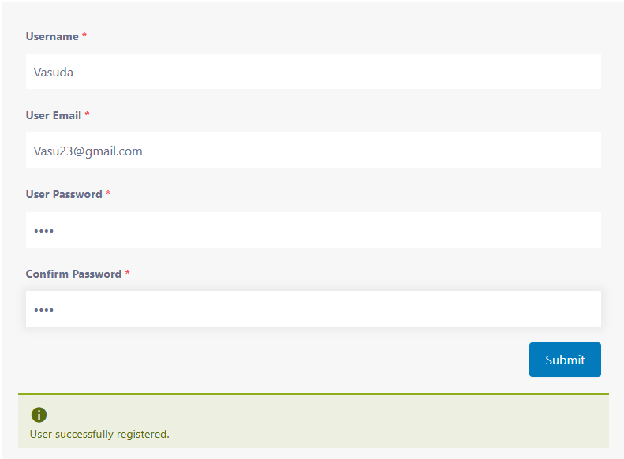
Environment | Application Version: 1.2.3  Browser: Google Chrome  Operating System: Windows 11
Defect Report

